1. Can add past dates for tasks

Steps to reproduce:

* Click + icon
* Add title
* Select a past date
* Click on ‘Add new task’ (For some reason can add empty description, might be intentional)

Actual vs Expected behavior: It should prevent from entering past dates, but I does not prevent it.

Severity Level: Medium

Screenshot

2. When I sign up and login, the data is lost

Steps to reproduce:

* Create some random task (don’t login yet)
* Create new account and login
* Observe the task list, its empty

Actual vs Expected behavior: It should persist the data after login, but it does not persist it.

Severity Level: High

Screenshot

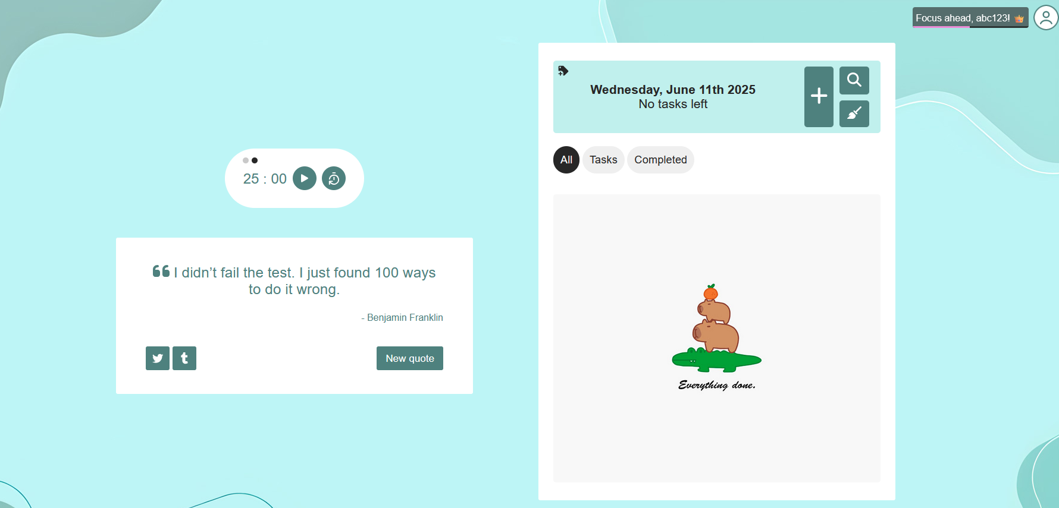

3. When I click on randomly anywhere in the page, it says to confirm discard changes, even if clicked on start timer, reset timer.

Steps to reproduce:

* Create some random task but don’t add it yet.
* Enter some random data
* Click on start timer or stop timer
* Observe the task list, its empty

Actual vs Expected behavior: Although it is expected that this should be shown when clicking somewhere random, but this behavior should not be shown when clicking on functionality such as start or stop timer.

Severity Level: Low

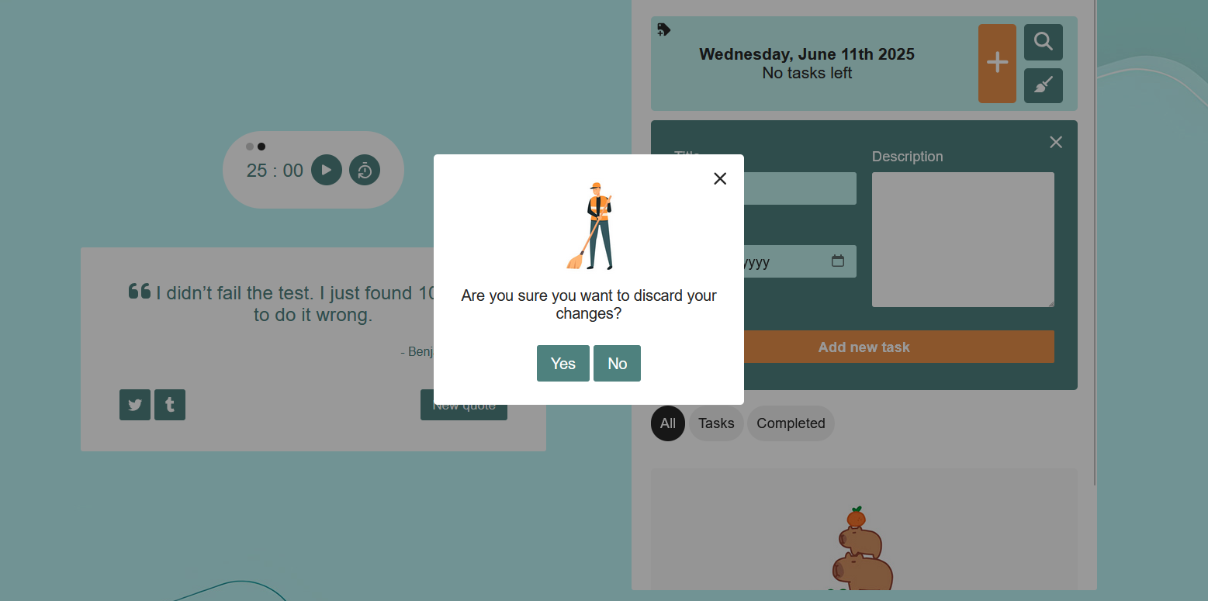

4. Added the title as ‘0’, but still says field required (only when login)

Steps to reproduce:

* Ensure login (For some reason only happens when login)
* Enter 0 in title field
* Add new task

Actual vs Expected behavior: The title should be added.

Severity Level: High/Low depending on why this happened, but should be considered high.

5. Duplicate Entries allowed

Steps to reproduce:

* Add some random task
* Duplicate the task previously added task details in new task and add it.
* Duplicate entries would be there in the task list.

Actual vs Expected behavior: The title should be unique for unique dates, however this is not the case.

Severity Level: Low

6. Summary

5 bugs were tested which were related to dates, data persistence, a basic quirk which seems to be intentional although some fields shouldn’t replicate this behaviour, title not accepting 0 as a title this would not be a concern however this only happens when login, and the last bug which allowed duplicate entries.

* The first bug can be fixed with simple javascript(Maybe)
* The second bug needs to be fixed in backend
* Third bug is optional to be fixed at the moment, but would be nice if it is.
* Fourth bug seems to be a backend issue, there might be some data leak where unauthorized fields are utilizing user data(a guess).
* Fifth task can be fixed in the backend by checking if a task already exists with the same date (Upper case or lower case titles should be distinguished, although depends on use case).

7. Testcase Table

|  |  |  |  |  |  |
| --- | --- | --- | --- | --- | --- |
| **Test Case ID** | **Scenario Description** | **Steps** | **Expected Result** | **Actual Result** | **Status** |
| TC01 | Add task with past date | Click + → Enter title → Select past date → Click "Add new task" | App should prevent past dates | Task with past date added successfully | Fail |
| TC02 | Task disappears after login | Create task (while not logged in) → Login | Task should persist | Task list is empty after login | Fail |
| TC03 | Confirmation popup on clicking “Start Timer” | Create task but don’t save → Click “Start Timer” | Timer starts, no discard popup shown | Popup appears asking to confirm discard, even if clicked yes or no, timer does not starts. | Fail |
| TC04 | Title “0” not accepted (while logged in) | Log in → Enter title: "0" → Add new task | Task should be added | Website says "Field required" | Fail |
| TC05 | Duplicate task entries allowed | Add task → Add same task again | Duplicate tasks with same title and date should not be allowed | Both tasks are added | Fail |

8. Footnotes:

All the tests were performed both on chrome and Firefox, reproducible on both, furthermore, it seems there is no issue with display that can shrink the size of screens in both browsers and there is no issue in both. The website behaves the same in both browsers.